# Great Horn Rats Site Plan

## [Elliott VanOrman]

## WDD 130

## Overview

### Purpose

The purpose of my website is to allow people to purchase live rats in bulk. That is my only purpose.

### Audience

My target audience consists of the following people:

-Somewhat mentally ill rat enthusiasts. They desire as many rats as they can have as quickly as possible. As such, we should advertise quick rat sale times.

-Laboratories, seeking as many rats as possible for testing purposes. As such, multiple species of rats can be sold from ages young to old, and in a good state or in random state. (good quality rats should cost more)

-People seeking to lower their property values for whatever reason. They desire hardy, non-domestic rats, (potentially infected with diseases) to best get inside a building and stay there. As such, we should offer caught rats alongside farmed rats, but at a higher price, as well as terms and conditions stating that the buyer must have the legal consent of the property owner to release rats on a property.

## Branding

### Website Logo



## Style Guide

### Color Palette

|  |  |  |  |
| --- | --- | --- | --- |
| **Primary** | **Secondary** | **Accent 1** | **Accent 2** |
| 523D00 | 92817A | F1DABF | 00FF00 |

### Typography

#### Heading Font: Papyrus, Courier Prime, Serif

#### Paragraph Font: Ariel, Sans Serif

### Navigation

Home Order Form Ratalouge

**Content Below:**

**Home:**

Opening Paragraph:

Have you ever found yourself in need of a large number of live rats on short notice, only to look online and find nothing but pricey feeder and pedigree rats in nowhere near the quantities you needed? Or did you want someone to help guide you through the process of making sure your huge number of rats were settled in properly? Well then we have an offer for you. Here at Great Horn Rats Inc, we specialize in delivering as many rats as you could want in record times and at great prices. Whether you’re looking for a uniform set of rats for experimentation, a non-invasive mix for pest control, or cute and docile for therapy or companionship, We have what you need. We can get whatever you need in specific quantities or by the pound, fresh-caught or farmed, with whatever demographic mix you need, be it all-male, all-female, day-old or years-old, at your door within 7 days of initial order. Buy now!

Hero image:

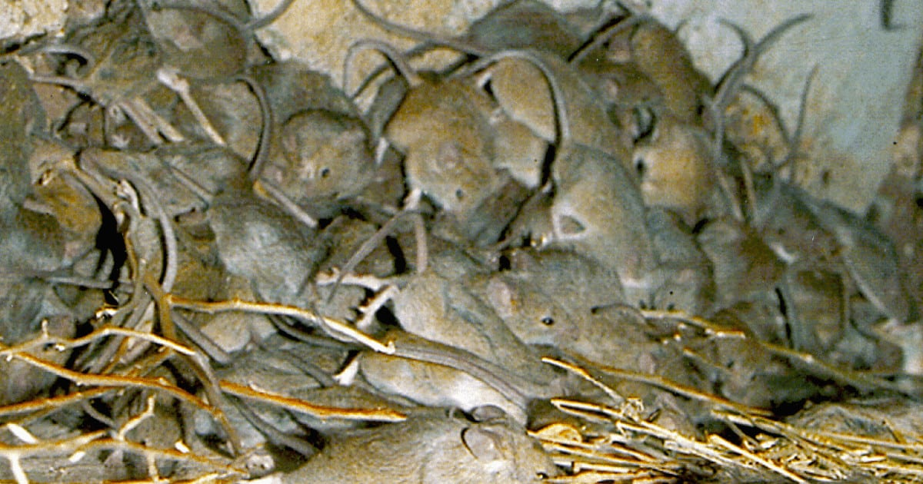  
Labels and Buttons:

Ready to buy?

[Fill out our order form!]

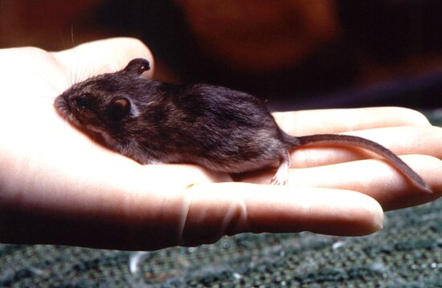

Wondering about price or not sure on what to buy?:

[Check our Ratalog!]

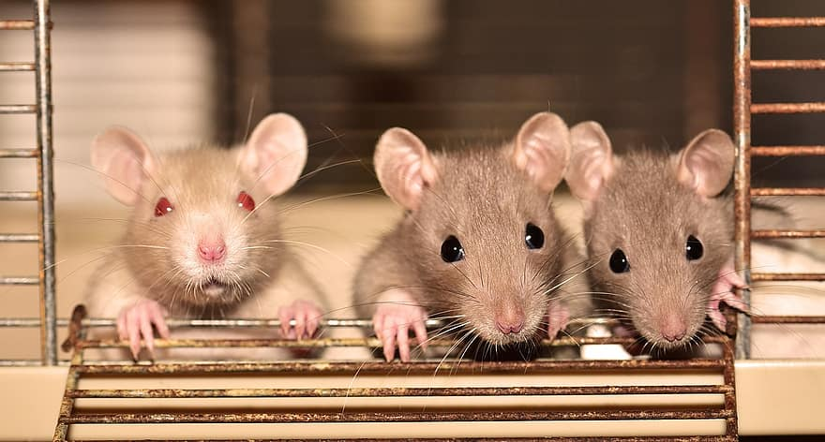

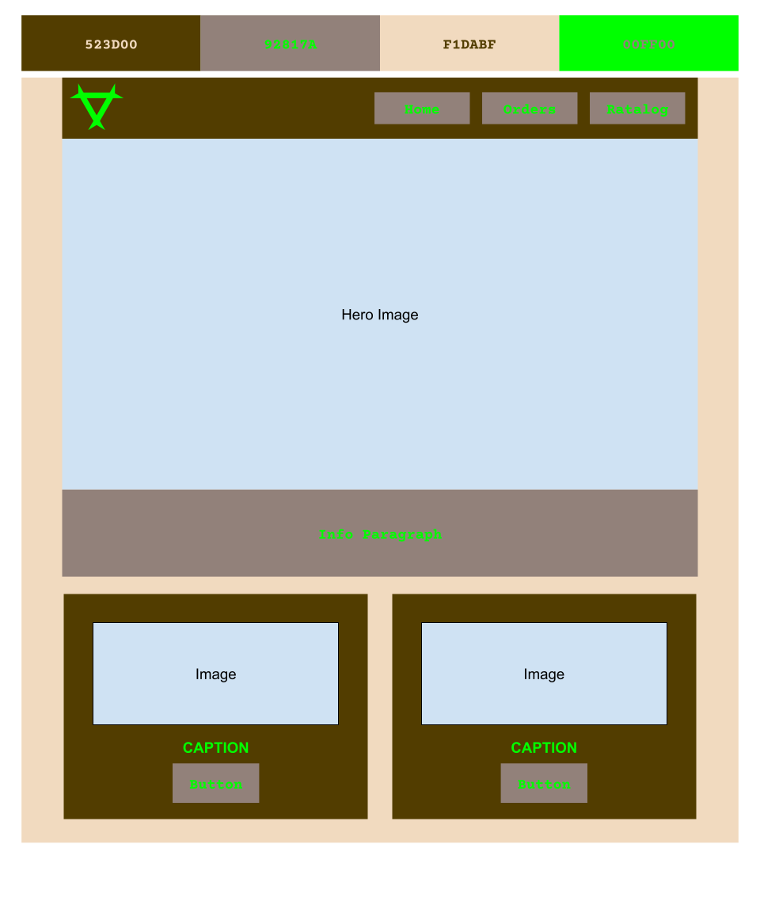

**Order:**

Most of text appears in the wire frame. You can either make up prices and species or use the spreadsheet attached in this file. If you want to you can do the JS to make the calendar work, but if you don’t want to you don’t need to. Just replace it with the images below.

Calendar images:



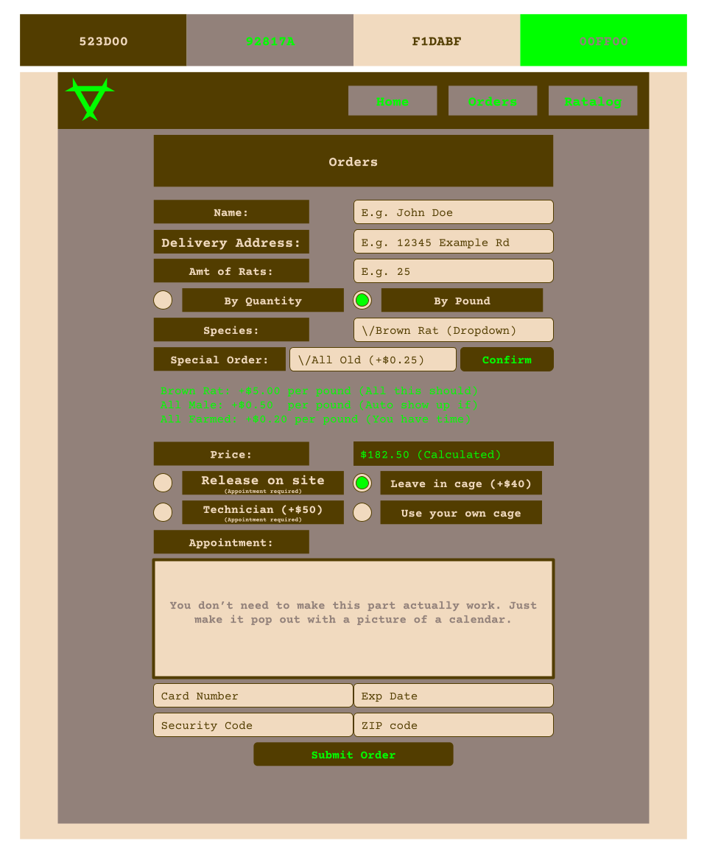

**Ratalaog:**

Rat Images, Names, and prices are attached underneath this wireframe:

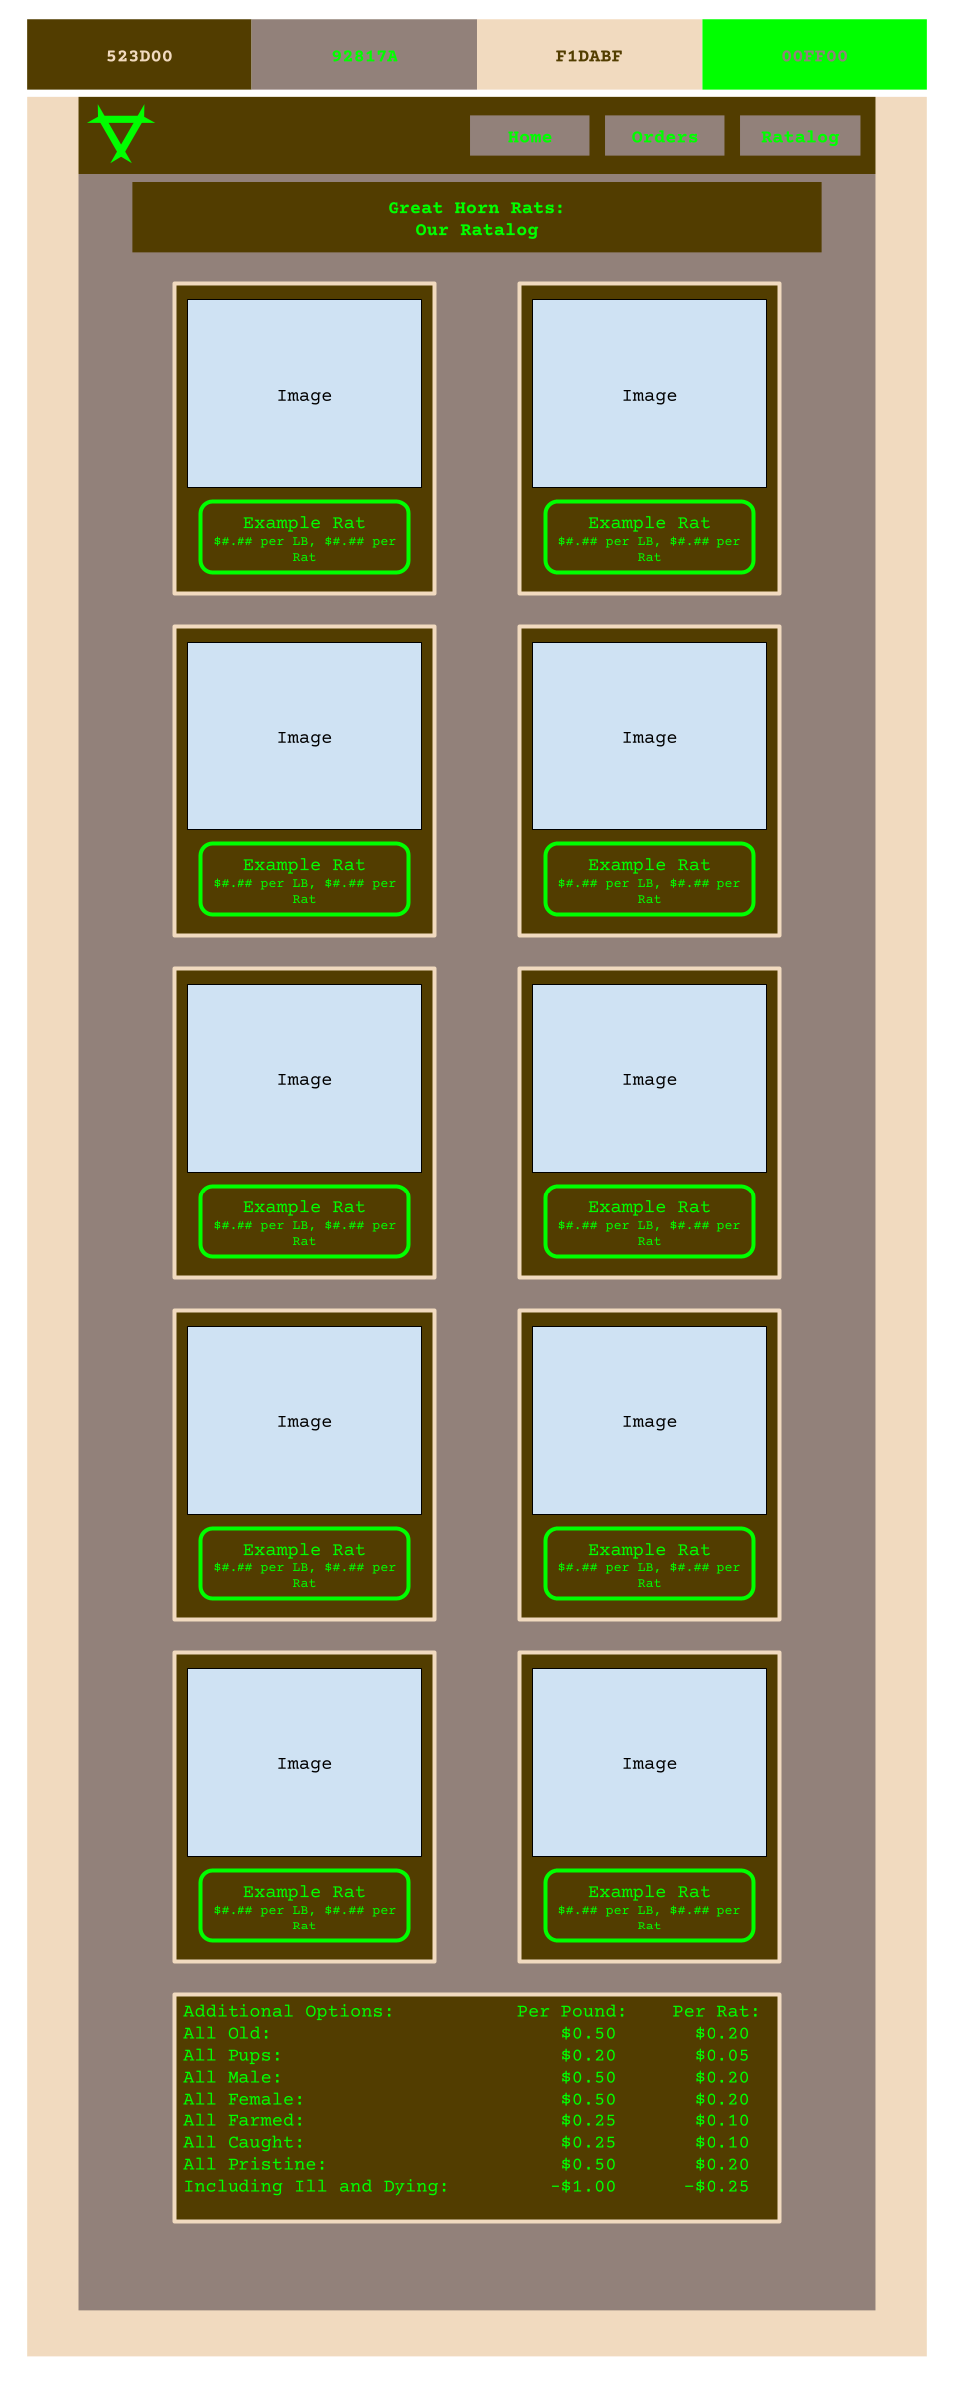

Rat Price Grid

|  |  |  |  |
| --- | --- | --- | --- |
| Species/Additional Option | Per Pound | Per Individual | Pictures: |
| Brown Rat | $5.00 | $2.00 |  |
| Black Rat | $10.00 | $1.00 |  |
| Fancy Rat | $7.50 | $3.00 |  |
| Cotton Rat | $5.00 | $1.00 |  |
| Pack Rat | $6.00 | $3.50 |  |
| Marsh Rice Rat | $12.00 | $0.50 |  |
| East Woodrat | $6.00 | $3.50 |  |
| Wistar Rat | $10.00 | $4.00 |  |
| Sprague Dawley Rat | $10.00 | $4.00 | ­ |
| Wooly Mouse | $40.00 | $8.00 |  |
| AO: All Old | $0.50 | $0.20 |  |
| AO: All Pups | $0.20 | $0.05 |  |
| AO: All Male | $0.50 | $0.20 |  |
| AO: All Female | $0.50 | $0.20 |  |
| AO: All Farmed | $0.25 | $0.10 |  |
| AO: All Caught | $0.25 | $0.10 |  |
| AO: All Pristine | $0.50 | $0.20 |  |
| AO: Including Ill and Dying | -$1.00 | -$0.25 |  |